**UML Class Diagram**

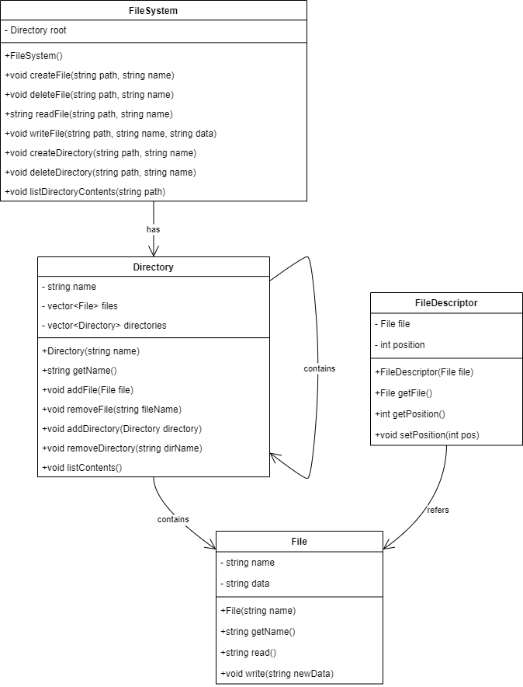

**Class Diagram Overview: File System**

File Class:

• Attributes: Name, data, creation constructor, read(), write(string newData).

• Methods: File (string name), getName(), read(), write(string newData).

Directory Class:

• Attributes: Name, files, directories.

• Methods: Directory(string name), getName(), addFile(File file), removeFile(string fileName), addDirectory(Directory directory), removeDirectory(string dirName).

FileSystem Class:

• Attributes: Root, primary hard drive partition or disk.

• Methods: FileSystem(), createFile(string path, string name), deleteFile(string path, string name), readFile(string path, string name), writeFile(string path, string name, string data), createDirectory(string path, string name), deleteDirectory(string path, string name).

FileDescriptor Class:

• Attributes: File, position.

• Methods: FileDescriptor(File file), getFile(), getPosition(), setPosition(int pos).

Relationships: FileSystem to Directory, Directory to File, Directory to Directory, FileDescriptor to File.

**Use Case Diagram**

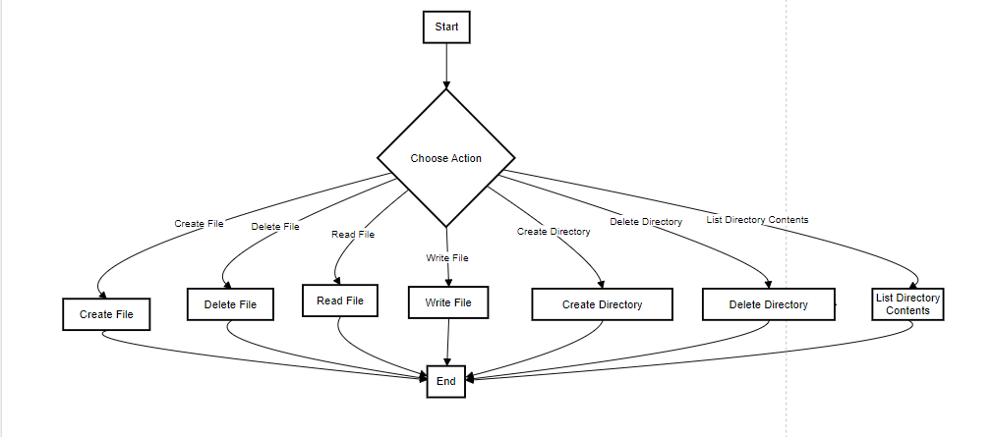

The next figure shows a representation of a basic flowchart of a user operate meaning decide what to do next in a filesystem. Here's the description of each element and the overall flow:

Start: This suggests the flowchart’s starting point, meaning that the user is willing to perform an action.

User Decision: The user is provided with options that they can which actions on the filesystem. These actions include:

Create File

Delete File

Read File

Write File

Create Directory

Delete Directory

List Directory Contents

Actions:

Create File (CF): The user decides to create a new file in the filesystem/ The user implicitly selects the option of creating a new file out of the filesystem.

Delete File (DF): file A is to be deleted by the user.

Read File (RF): The user wants to read something out of a file.

Write File (WF): The user decides to write new data to a file.

Create Directory (CD): The GUI created by the user makes the decision to create a new directory.

Delete Directory (DD): B The user wants to remove a given directory.

List Directory Contents (LDC): The user has a definite need to perform a directory listing.

End: Every action, in some way or another, results in the GO TO end label which informs the user that the chosen operation has been executed.

This flowchart is effective in presenting all the options a user can take on the filesystem and the decisions that relate to it.